Experiment No. 1
Generation and Classification of Continuous-Time and Discrete-Time Signals

1.2. To generate and visualize basic discrete-time signals and analyze their amplitude and time-index characteristics.

Experimental procedure :
- Define the integer sample index n. Qualitative match
- Generate unit impulse, unit step, ramp, exponential and sinusoidal sequences.
- Display each sequence using a stem plot.
- Determine sample amplitudes and period where applicable.
- Classify the sequence as periodic/non-periodic and even/odd wherever applicable. Compare the generated samples with theoretical values and record observations.

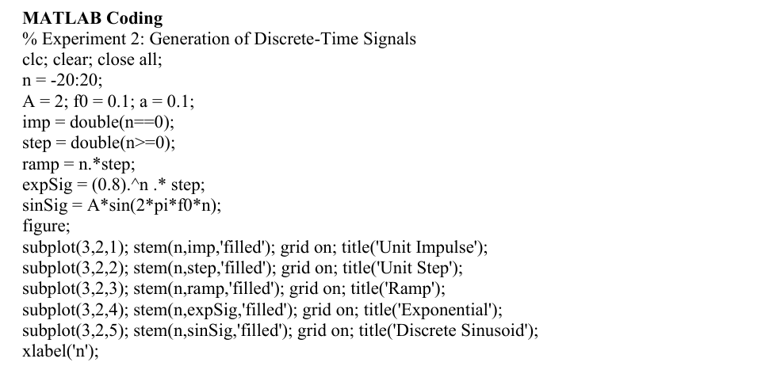

Output:
